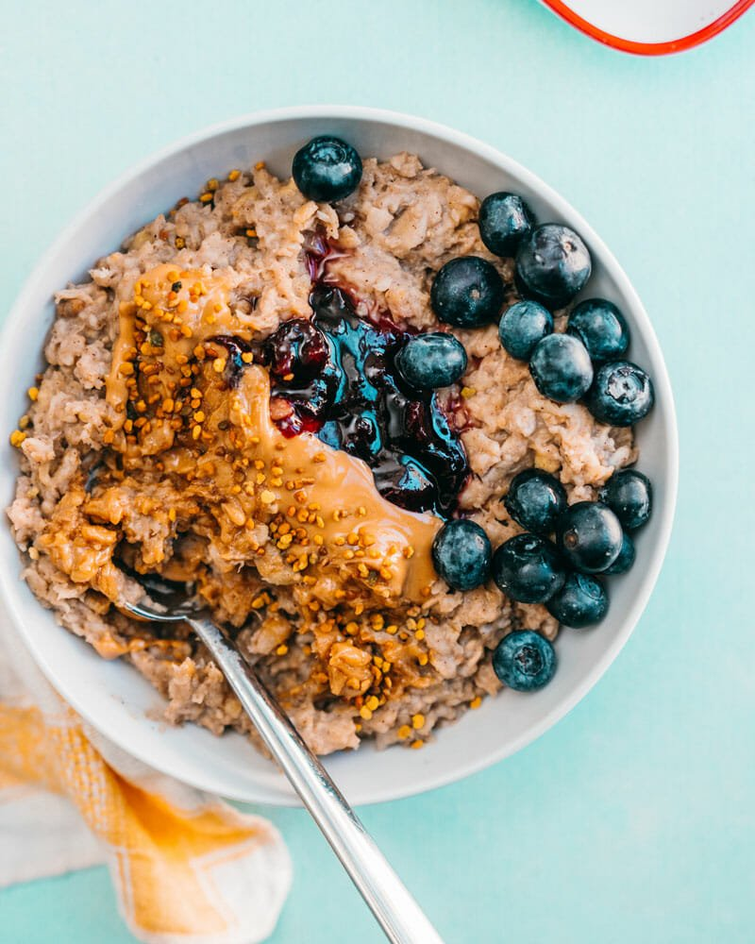Peanut Butter Oatmeal

|  |
| --- |
| Ingredients With Measurements  * 1 tablespoon coconut oil * 2 cups Old Fashioned rolled oats * ¼ teaspoon kosher salt * 1 teaspoon cinnamon * 1 cup water * 1 cup almond milk * 2 tablespoon peanut butter |

|  |
| --- |
| Recipe Melt the coconut oil in a saucepan over medium heat. Add the oats and toast for about 2 to 3 minutes, stirring often, until fragrant.  Add the salt and cinnamon. Turn the heat to low and carefully pour in the water and milk, stirring. Add the mashed banana, if using. Cover and cook for 5 minutes until tender, then remove from the heat. Serve immediately for a chunky texture, or stir in an additional ½ cup milk for a creamier body. Top with the peanut butter. |

|  |  |  |  |  |  |  |  |
| --- | --- | --- | --- | --- | --- | --- | --- |
| |  |  | | --- | --- | | Coconut Oil | Old Fashioned Rolled Oats | | Salt | Cinnamon | | Water | Almond Milk | | Peanut Butter |  Ingredients Without Measurements |